

**Carrier 3.0HP A5CK 28E/A5LC 28C**

**Rs. 87,600/-**

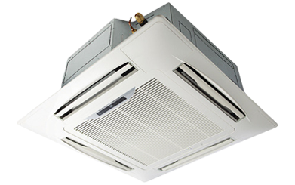

**Product Features**

* Reserved Air Outlet
* State of the Art
* Air Vane Technology
* Auto Swing
* power mode

**Specification**

**Type** Ceiling Cassette AC

**Cooling (Btu/h)** 51000

**Voltage (V)** 220-240

**Power Input (W)** 4600

**EER (Btu/W-h-W/W)** 7.2-3.45